Project Report Format

- INTRODUCTION

  - Project Overview

The Dog Breed Identification system is a deep learning application that classifies dog breeds from images using transfer learning. The project uses a pre-trained Convolutional Neural Network (VGG19) to identify dog breeds based on visual features such as fur pattern, ear shape, and facial structure.

  - Purpose

The purpose of this project is to develop an automated system that can accurately identify dog breeds from images, reducing manual effort and demonstrating the practical application of artificial intelligence in image classification.

- IDEATION PHASE

  - Problem Statement

Identifying dog breeds manually from images is difficult and time-consuming due to similarities between breeds. An automated system is required to accurately classify dog breeds using machine learning techniques.

  - Empathy Map Canvas

Users such as pet owners, veterinarians, and researchers need an easy way to identify dog breeds from images. They expect quick, accurate results without requiring technical knowledge.

  - Brainstorming

Possible solutions included manual identification systems, traditional machine learning models, and deep learning approaches. Transfer learning using CNN was chosen for higher accuracy.

- REQUIREMENT ANALYSIS

  - Customer Journey map

User uploads an image → System processes image → Model predicts breed → Result displayed to user.

  - Solution Requirement

- Dog image dataset
- Deep learning model
- Web interface for user interaction

  - Data Flow Diagram

Input image → Preprocessing → CNN Model → Prediction → Output display

  - Technology Stack

Python, TensorFlow, Keras, Flask, HTML, CSS

- PROJECT DESIGN

  - Problem Solution Fit

Transfer learning enables accurate breed identification even with limited training data by leveraging pre-trained models.

  - Proposed Solution

A web-based application that accepts dog images and predicts the breed using a trained VGG19 model.

  - Solution Architecture

User Interface → Flask Server → Preprocessing → CNN Model → Prediction → Output

- PROJECT PLANNING & SCHEDULING

  - Project Planning

The project was completed in four sprints: data preparation, model development, application development, and testing.

- FUNCTIONAL AND PERFORMANCE TESTING

  - Performance Testing

The system was tested for prediction accuracy, response time, and ability to handle multiple image inputs.

- RESULTS

  - Output Screenshots

The application successfully predicts dog breeds with confidence scores through a web interface.

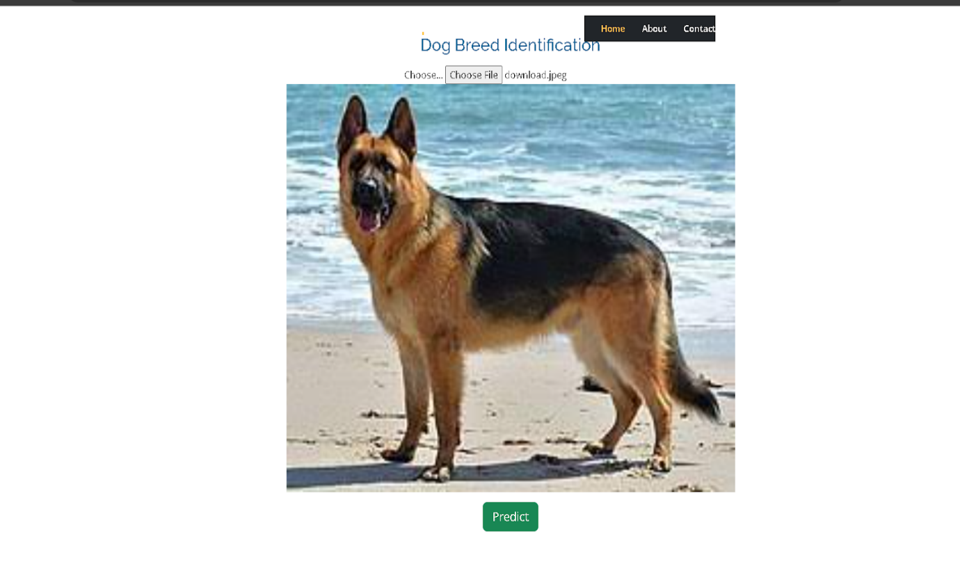

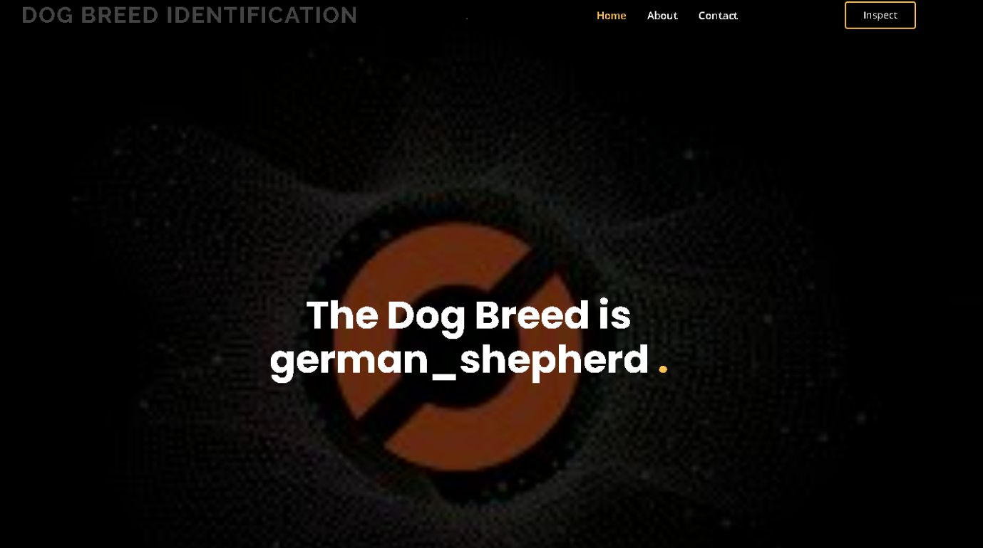

- ADVANTAGES & DISADVANTAGES

Advantages

* High accuracy using transfer learning
* Automated breed identification
* User-friendly interface

Disadvantages

* Requires good quality images
* Limited to trained breeds

- CONCLUSION

The Dog Breed Identification system demonstrates how transfer learning can be used to build efficient image classification applications with high accuracy and reduced training time.

- FUTURE SCOPE

- Support more dog breeds
- Mobile application development
- Real-time camera detection

11. APPENDIX
Source Code:
import tensorflow as tf
import numpy as np
from tensorflow.keras.preprocessing import image
import streamlit as st
import pandas as pd

labels = pd.read_csv("labels.csv")
class_names = sorted(labels["breed"].unique())

model = tf.keras.models.load_model("model/dog_breed_model.keras")

st.title("🐶 Dog Breed Identifier")

uploaded_file = st.file_uploader("Upload a dog image", type=["jpg","png","jpeg"])

if uploaded_file:
img = image.load_img(uploaded_file, target_size=(224,224))
img = image.img_to_array(img)/255
img = np.expand_dims(img, axis=0)

pred = model.predict(img)
breed = class_names[np.argmax(pred)]

st.write("Predicted Breed:", breed)

Dataset Link : https://www.kaggle.com/competitions/dog-breed-identification/data?select=train
GitHub : https://github.com/Sazia909/Dog_Breed_Identification_Using_Transfer_Learning
Project Demo Link : https://Dog_Breed_Identification_Using_Transfer_Learning.streamlit.app/

